**CDAC Mumbai PG-DAC August 24**

**Assignment No- 4**

1. Write a program that demonstrates widening conversion from int to double and prints the result.

public class WideningConversion {

public static void main(String[] args) {

int intValue = 10;

double doubleValue = intValue; // Widening conversion from int to double

System.out.println("The double value is: " + doubleValue);

}

}

1. Create a program that demonstrates narrowing conversion from double to int and prints the result.

public class NarrowingConversion {

public static void main(String[] args) {

double doubleValue = 9.99;

int intValue = (int) doubleValue; // Narrowing conversion from double to int

System.out.println("The int value is: " + intValue);

}

}

1. Write a program that performs arithmetic operations involving different data types (int, double, float) and observes how Java handles widening conversions automatically.

public class ArithmeticOperations {

public static void main(String[] args) {

int intValue = 5;

float floatValue = 4.5f;

double doubleValue = 3.14;

// Adding different data types

double result = intValue + floatValue + doubleValue;

System.out.println("The result of the arithmetic operation is: " + result);

}

}

4) Write a Program that demonstrates widening conversion from int to (double,float, boolean, string) and prints the result.

public class WideningConversions {

public static void main(String[] args) {

int intValue = 42;

// Widening conversion to double

double doubleValue = intValue;

System.out.println("The double value is: " + doubleValue);

// Widening conversion to float

float floatValue = intValue;

System.out.println("The float value is: " + floatValue);

// Widening conversion to String

String stringValue = Integer.toString(intValue);

System.out.println("The String value is: " + stringValue);

// Note: Widening conversion to boolean is not applicable

}

}

**Interview Questions**

**Note: Write down this interview question on your notebook ,Take a screenshort & Paste that SS in the word document & upload on your Github.**

1. What does the static keyword mean in Java? Explain the difference between static and non-static methods.

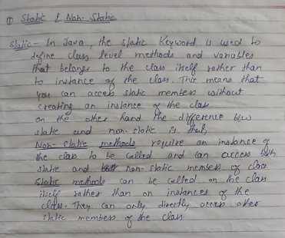

1. What is the role of the static keyword in the context of memory management.

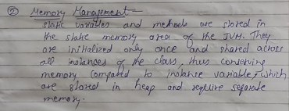

1. Can static methods be overloaded and overridden in Java?Howstatic variables shared across multiple instances of a class?

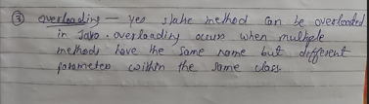

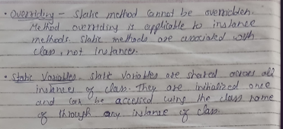

1. What is the significance of the final keyword in Java?

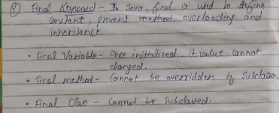

1. What are narrowing and widening conversions in Java?

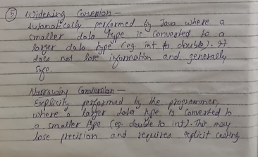

1. Provide examples of narrowing and widening conversions between primitive data types.

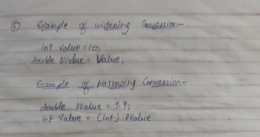

1. How does Java handle potential loss of precision during narrowing conversions?

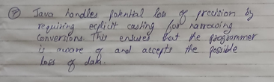

1. Explain the concept of automatic widening conversion in Java.

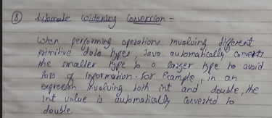

1. What are the implications of narrowing and widening conversions on type compatibility and data loss?

